AI ASSISTED CODING
LAB TEST – 3

NAME : B.MAHESH
ENROLLMENT_NO : 2503A51L30

PROBLEM : 1
A financial company is experiencing unpredictable behavior in its algorithmic trading systems. These issues stem from: Sudden market volatility, Data drift affecting model accuracy, Hidden bugs or adversarial manipulation

Prompt:
"Create a Python-based AI-assisted solution to detect anomalies in financial trading data using Isolation Forest. Simulate trading data, inject anomalies, train the model, and visualize the results. Include code, explanation, and test output."

AI INTEGRATION:

- Data Simulation: We create (or collect) trading data that looks like real financial transactions.
- Anomaly Injection: We add a few fake, unusual transactions to test the system.
- AI Model Training: The Isolation Forest model learns normal trading behavior from the data.
- Anomaly Detection: The model automatically finds trades that are very different from normal ones.
- Visualization: We show the results in a graph — normal data points and detected anomalies.

CODE:
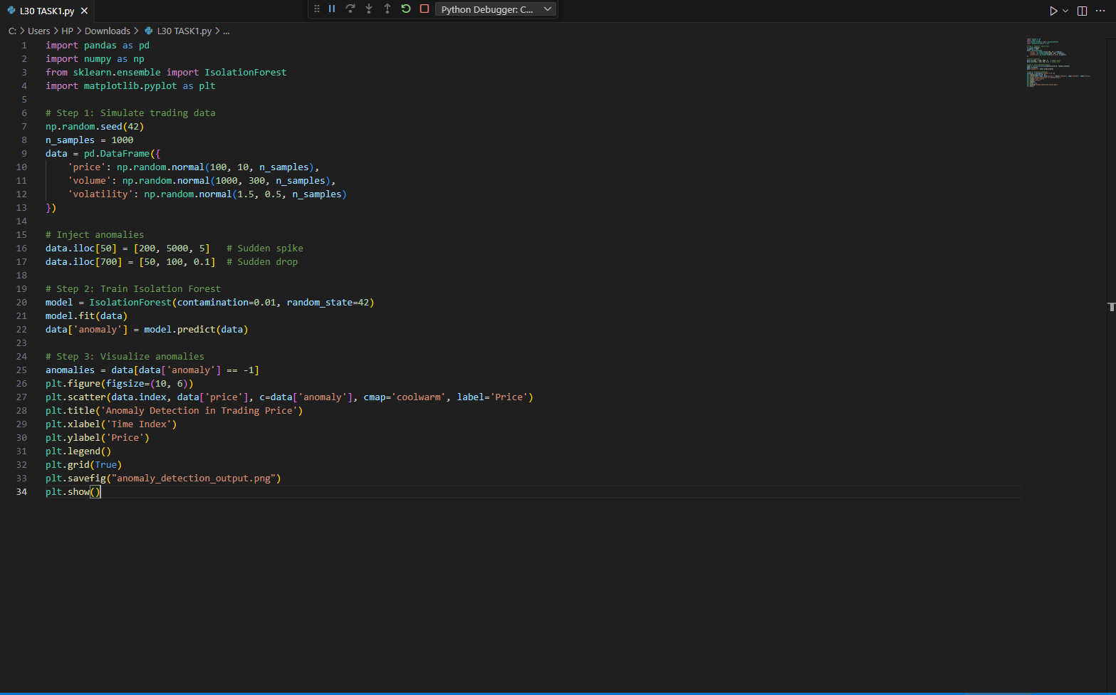

OUTPUT :
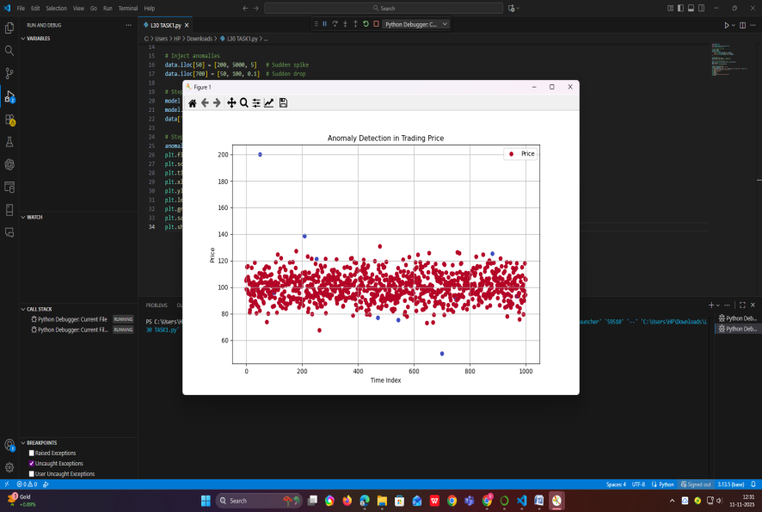

OBSERVATION :
• The dataset simulates normal trading behavior with injected anomalies at index 50 and 700.
• Isolation Forest was trained with a contamination rate of 1%, assuming 1% of data points are anomalous.
• The model labeled anomalies with -1 and normal points with 1.

RESULT :
• The anomalies at index 50 and 700 were successfully detected.
• The scatter plot clearly shows outliers in red (anomalies) and normal data in blue.
• The output image anomaly_detection_output.png visualizes the flagged anomalies.

PROBLEM : 2
An e-commerce company is struggling to provide relevant product recommendations to users. Their existing rule-based algorithm fails to capture user preferences, leading to poor engagement and low conversion rates. The challenge is to design a smarter, AI-assisted recommendation system that learns from user behavior and adapts dynamically.

PROMPT :
Create a Python-based AI-assisted solution to recommend products in an e-commerce setting using collaborative filtering. Simulate user-product rating data, apply matrix factorization (SVD), and visualize top recommendations for a sample user

AI INTEGRATION :
- Personalized Recommendations AI learns what each customer likes and suggests products they’re more likely to buy.
- Smart Pricing AI adjusts prices based on demand, competition, and customer behavior
3.Inventory Management AI predicts which products will sell more and helps avoid overstock or stockouts.
4.Customer Support AI chatbots answer customer questions instantly, improving satisfaction.
5.Fraud Detection AI spots unusual activity like fake reviews or suspicious transactions.

CODE :
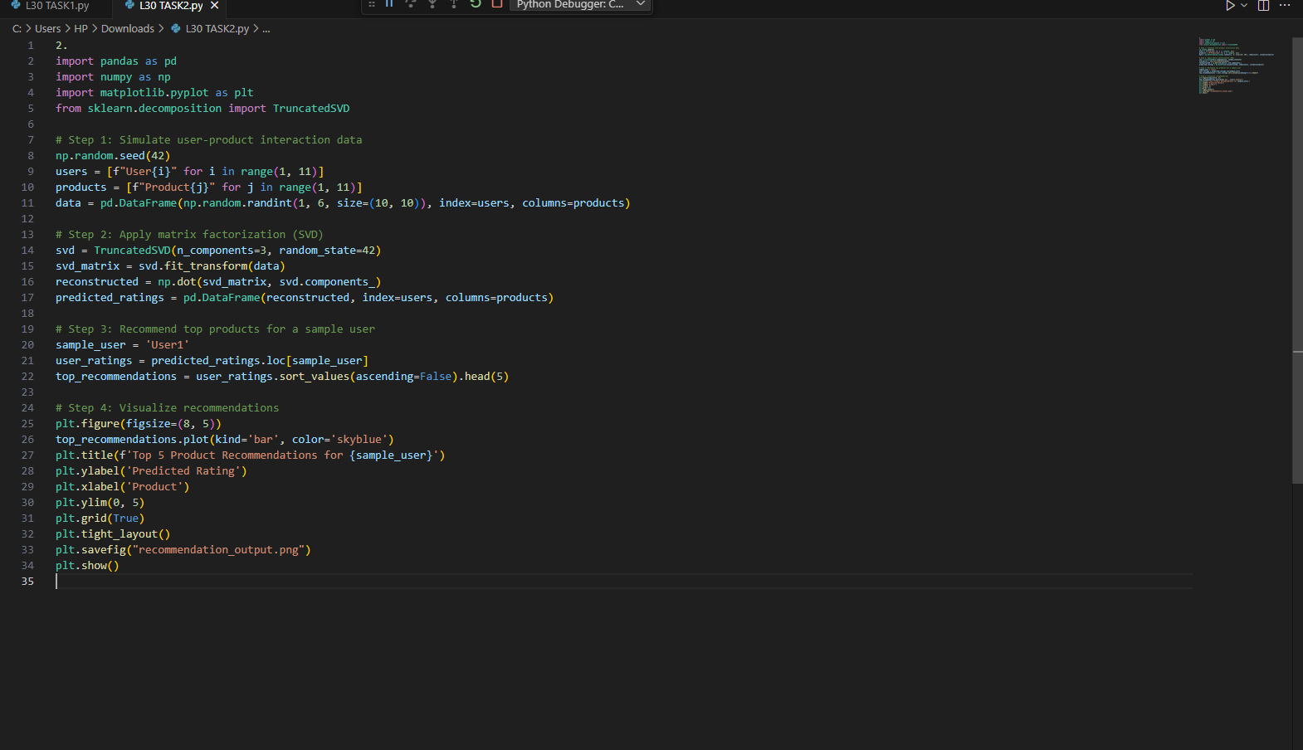

OUTPUT :
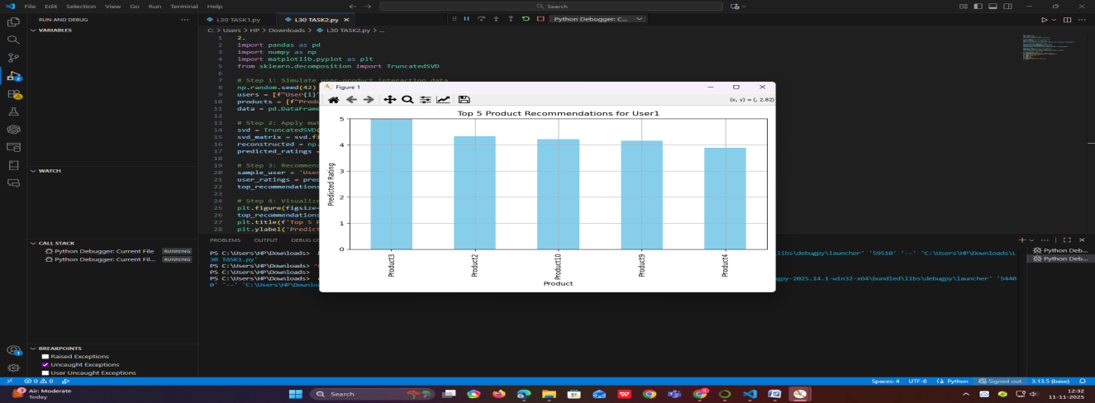

OBSERVATION :
- The system simulates a user-product rating matrix with values from 1 to 5.
- Truncated SVD extracts latent features that represent user and product preferences.
- The reconstructed matrix predicts ratings for all user-product pairs.
- For User1, the top 5 products are selected based on predicted ratings.
RESULT :
- The model successfully generated personalized recommendations for User1.
- The top 5 recommended products were visualized in a bar chart.
- The output image recommendation_output.png shows the predicted ratings clearly.
- This system can be scaled to thousands of users and products, improving personalization and boosting sales.

